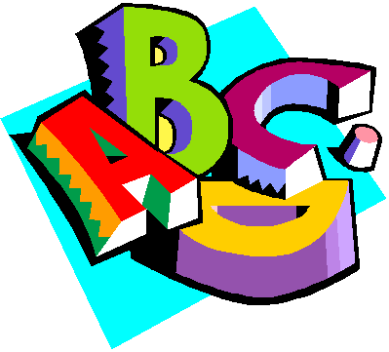
Preschool Newsletter
Week of October 3
Snack: Colton Thank you!
We will be reviewing the letters A M and S and reviewing numbers 1 and 2 circle and squares
THERE IS NO SCHOOL THURSDAY FOR PRESCHOOL
PLEASE CHECK YOUR SCREENING TIME!
Tuesday October 4th Library with Mrs. Bratland Please bring library book back!
Wednesday Music
Snack Week of October 10th Gracie
There are 14 students for snack
We had a fun week by attending the pep rally and a super show and tell day with all the S items! We had snickers, suckers with grandpa Stan, songs, Samantha the doll, santa and sunglasses!
I hope your kiddos are having as much fun learning in preschool as I am!
If you have any questions email me diane.anderson@k12.sd.us

