Preschool Newsletter
Please read entire newsletter as there a couple fun upcoming events!
Snack: Ella
There are 14 students for snack!
We will be studying the letter N, number 6 and triangle
Our Reading Theme will be: Making Friends
We will be talking about people from other countries
Tuesday Library with Mrs. Bratland Please bring library book back!
Wednesday: Music
Thursday: PE Show and Tell The letter “N”
SHOES!!
Please have an extra pair here as we will want to change into tennis shoes from mud and snow boots!
TURKEY TROT
On November 17th at 2:00 the kindergarten and pre-school classes will walk a mile outside and have a snack following the walk. Parents are invited to join us on the trot/walk!
PILGRIM/INDIAN Feast
On November 22 the Indians (kindergarten class) have invited the Pilgrims (preschool class) to a feast! We will be dressing up as pilgrims. Please try to dress your child in black pants and a black shirt if possible. I will be sewing aprons for the girls to wear and we will make pilgrim hats for the boys.
Snack for Week of November 15th Kason

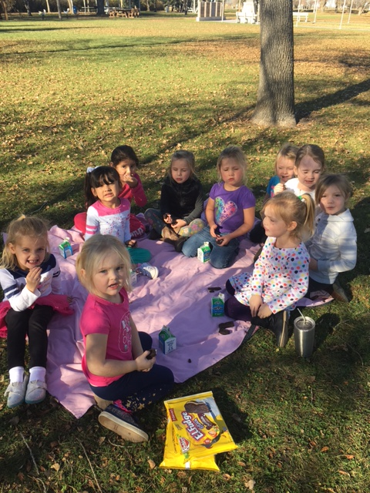 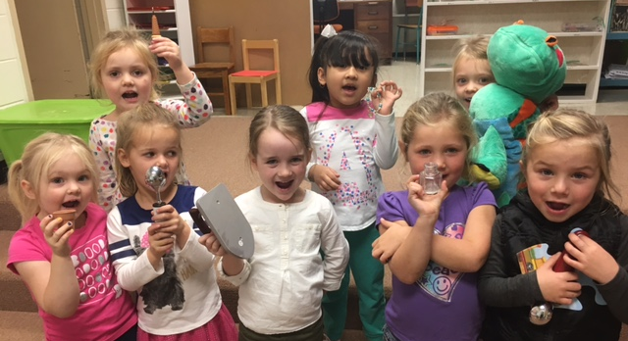 Picnic outside on November 3rd! Letter I Ice scream scoop, iron, iguana, letter puzzle I, indigo ice cream cone, ink well

