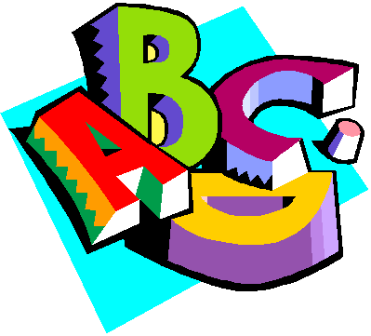
Preschool Newsletter
Week of October 11th
Snack: Gracie Thank you!
We will working on the letter P and the rectangle shape.
We will begin talking about Parts of the Body and compare and contrasting toes and fingers
Tuesday October 11th Library with Mrs. Bratland Please bring library book back!
Wednesday Music
Thursday PE and at 1:00 we will be going to the Fire Station
Week of October 18 Snack will be Katie Ammons
There are 14 students for snack
Once a month the 5th graders will be reading to us! Here are a few pictures!
If you have any questions email me diane.anderson@k12.sd.us
