Preschool Newsletter
THERE WILL BE NO PRESCHOOL OCT. 27 Due to PTC
A PTC schedule will be sent home. Please watch for it!
Week of October 18th
Snack: Millie Thank you!
We will working on the letter T and the number 4
Our Reading Theme will be: All about Me and My Family
Tuesday October 18th Library with Mrs. Bratland Please bring library book back!
Wednesday Music
Thursday PE and book orders are due! Show and tell for the letter T
There are 14 students for snack
We will be having a Halloween Party October 26th at 12:30. Your child will be allowed to dress up but please keep it simple so the costume won’t interfere with walking or going to the bathroom. Thank you!
We enjoyed our field trip to the fire station.
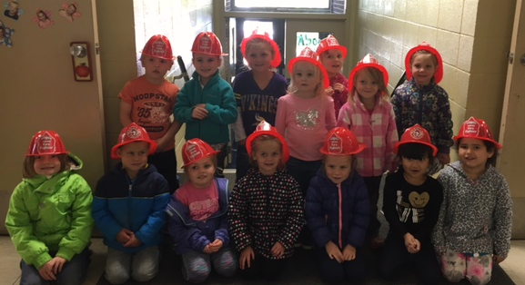 Fun with our fire hats!
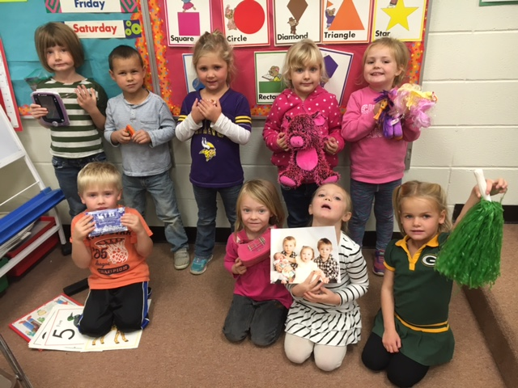 The letter P Packers, Pom pons, picture of family, popcorn, pink purse pepperoni pizza, pink pig, my little Ponies, purple tablet and pumpkin thanks for sharing

