- November 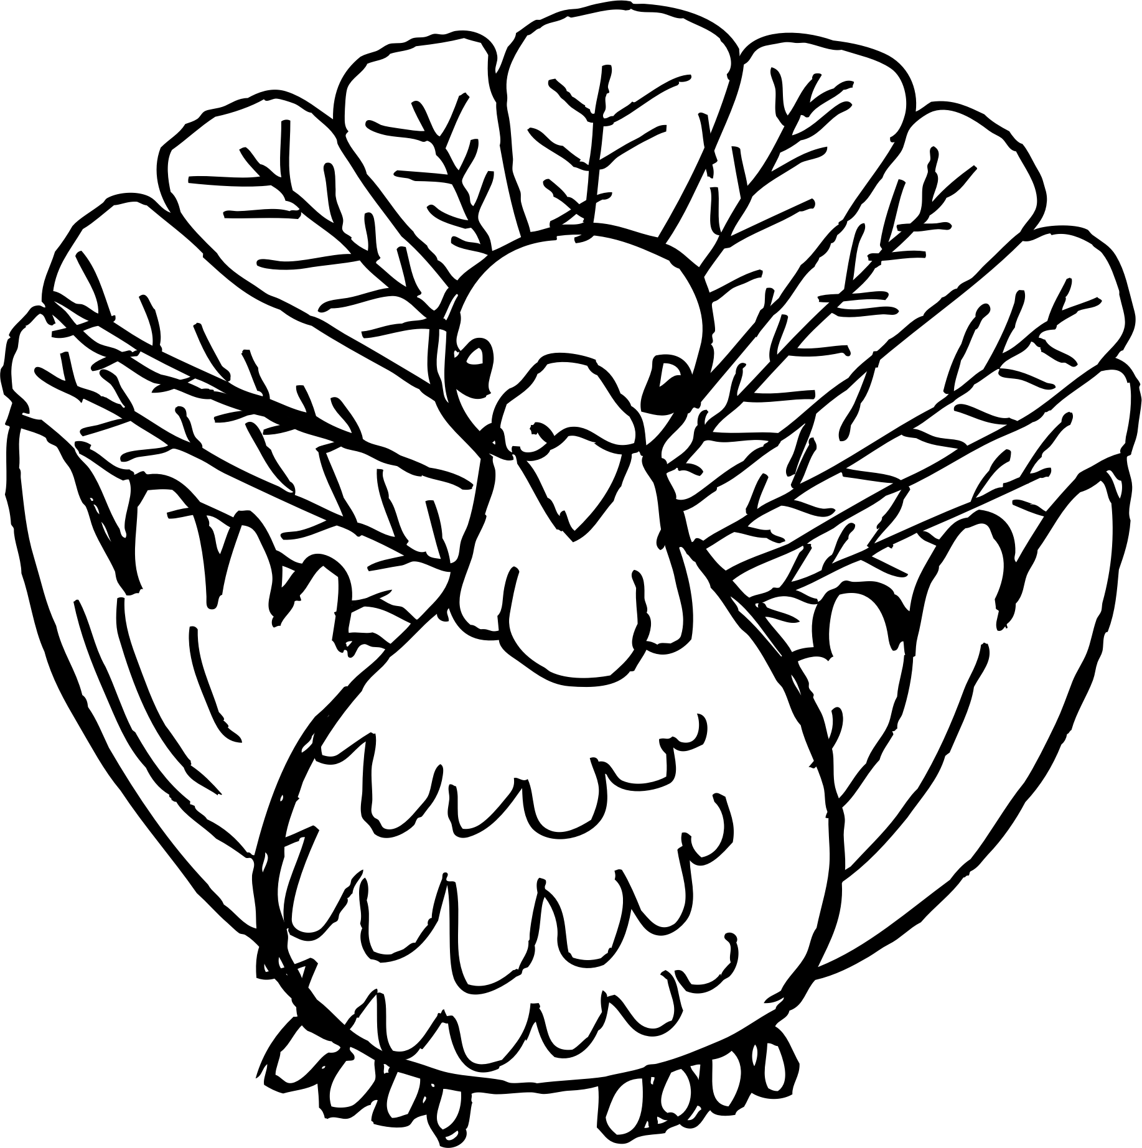 | 2016
Sunday | Monday | Tuesday | Wednesday | Thursday | Friday | Saturday
 |  | 1 | 2 | 3 | 4 | 5
 |  | Letter I  Sena Snack  Library Please bring books back | Music | PE  Show and Tell Letter I
6 | 7 | 8 | 9 | 10 | 11 | 12
 |  | Letter N  Ella Snack  Library Please bring books back | Music | PE  Show and Tell Letter N
13 | 14 | 15 | 16 | 17 | 18 | 19
 |  | Letter C  Kason Snack  Library Please bring books back | Music | PE  Show and Tell Letter  C
20 | 21 | 22 | 23 | 24 | 25 | 26
 |  | Review Letters I N C  Mrs. Anderson Snack  Library Please bring books back | Ho Preschool  1:00 Dismissal  Thanksgiving Break | Happy Thanksgiving!  No School
27 | 28 | 29 | 30 | DECEMBER 1
 |  | Letter F  Bridgette Snack  Library Please bring books back | Music | PE  Show and Tell Letter F

